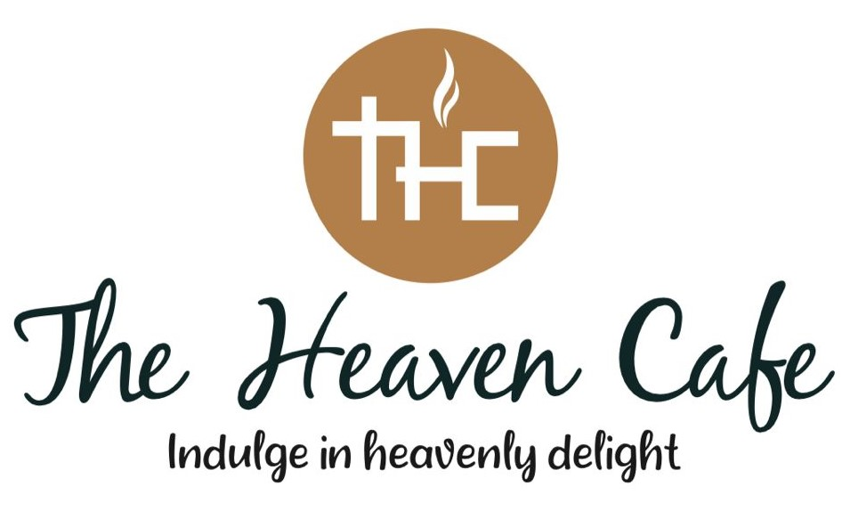

**The Heaven Cafe Classic Model:**

**Shop Area Requirement:** 300 sq. ft.

**Chef Requirement:** 2

# Product Inclusions:

1. **Cakes:** 3D Cakes, Photo Cakes, Shape Cakes & Deluxe Cakes
2. **Desserts:** Cupcakes, Doughnuts, Macaroons, Mousse, Pudding, Brownies, Pastries, Muffins, Cheesecakes, Tarts & Lava Cake.
3. **Chocolates & Cookies:** Multiple Varieties

**Cost to acquire Heaven Classic Model:** Rs.18,75,000 Lakhs + GST (300 sq. ft)

The cost for the franchise is subject to change depending on the size of the store (Rs.1.5 Lakhs + GST extra for every 100 sq. ft).

**The Heaven Cafe Classic Model with Seating (8 People):**

**Shop Area Requirement:** 350 sq. ft.

## Chef Requirement: 2

**Product Inclusions: Same as Classic Model**

**Cost to acquire Classic Model with Seating:** Rs.19,75,000 Lakhs + GST (350 sq. ft)

* 1. **The Heaven Café Plus Model:**

**Shop Area Requirement:** 550 sq. ft. to 1000 sq. ft. **Seating for:** 14-16 people (In a 550 sq. ft. Store) **Chef Requirement:** 3

# Product Inclusions:

1. **Cakes:** 3D Cakes, Photo Cakes, Shape Cakes & Deluxe Cakes
2. **Desserts:** Cupcakes, Doughnuts, Macaroons, Mousse, Pudding, Chocolates, Cookies, Brownies, Pastries, Muffins, Cheesecakes, Tarts & Lava Cake.
3. **Soft Serve Ice Creams + Ice Cream Desserts:** 13 Flavours + Ice Cream Desserts & Sundaes
4. **Belgian Waffles:** 10 Variants
5. **Savouries:** Puffs, Sandwiches, Rolls, Burgers, Breads, Danishes, Croissants, Quiches.
6. **Beverages:** Coffees, Coolers & Milkshakes (Each with multiple variants)

**Cost to acquire The Heaven cafe Plus:** Rs. 27 Lakhs + GST (550 sq. ft)

The cost for the franchise is subject to change depending on the size of the store (Rs.

1.5 Lakhs + GST extra for every 100 sq. ft)

* 1. **The Heaven cafe Food Plus Model:**

**Shop Area Requirement:** 550 sq. ft. to 1000 sq. ft.

**Seating for:** 14-16 people (In a 550 sq. ft. Store)

**Chef Requirement:** 4 to 5

# Product Inclusions:

* 1. **Cakes:** 3D Cakes, Photo Cakes, Shape Cakes & Deluxe Cakes
  2. **Desserts:** Cupcakes, Doughnuts, Macaroons, Mousse, Pudding,Chocolates, Cookies, Brownies, Pastries, Muffins, Cheesecakes, Tarts & Lava Cake.
  3. **Beverages:** Coffees, Coolers & Milkshakes (Each with multiple variants)
  4. **Continental:** Pizzas, Pasta, Burgers, Starters, Sandwiches, Hot Dogs, etc.
  5. **Chinese**: Soups, Starters, Main Course, Noodles, Rice, Chinese Sizzler, Chinese combo meals etc.* (at extra cost)

**Cost to acquire The Heaven cafe Food Plus:** Rs. 27 Lakhs + GST (550 sq. ft) *Rs 3 lakhs + GST extra for Chinese Cuisine.

The cost for the franchise is subject to change depending on the size of the store (Rs. 1.5 Lakhs + GST extra for every 100 sq. ft)

* 1. **The Heaven café Café Model:**

**Shop Area:** 600 sq. ft. to 1200 sq. ft.

**Seating for:** 18-22 people (In a 600 sq. ft. Store)

**Chef Requirement:** 5 to 6

# Product Inclusions:

* + 1. **Cakes:** 3D Cakes, Photo Cakes, Shape Cakes & Deluxe Cakes
    2. **Desserts:** Cupcakes, Doughnuts, Macaroons, Mousse, Pudding,Chocolates, Cookies, Brownies, Pastries, Muffins, Cheesecakes,

Tarts & Lava Cake.

* + 1. **Soft Serve Ice Creams + Ice Cream Desserts:**

13 Flavours + Ice Cream Desserts

* + 1. **Belgian Waffles:** 10 Variants
    2. **Beverages:** Coffees, Coolers & Milkshakes
    3. **Continental:** Pizzas, Pasta, Burgers, Starters, Sandwiches, Hot Dogs, etc.
    4. **Chinese**: Soups, Starters, Main Course, Noodles, Rice, Chinese Sizzler, Chinese combo meals etc.* (at extra cost)
    5. **Savouries:** Puffs, Sandwiches, Rolls, Burgers, Breads, Danishes, Croissants, Quiches.

**Cost to acquire The Heaven cafe Cafe:** Rs.30,95,000 Lakhs + GST (600 sq. ft) *Rs 3 lakhs + GST extra for Chinese

The cost for the franchise su.bject to change depending on the size of the store (Rs.1.5 Lakhs + GST extra for every 100 sq. ft).

## Thanks & Regards